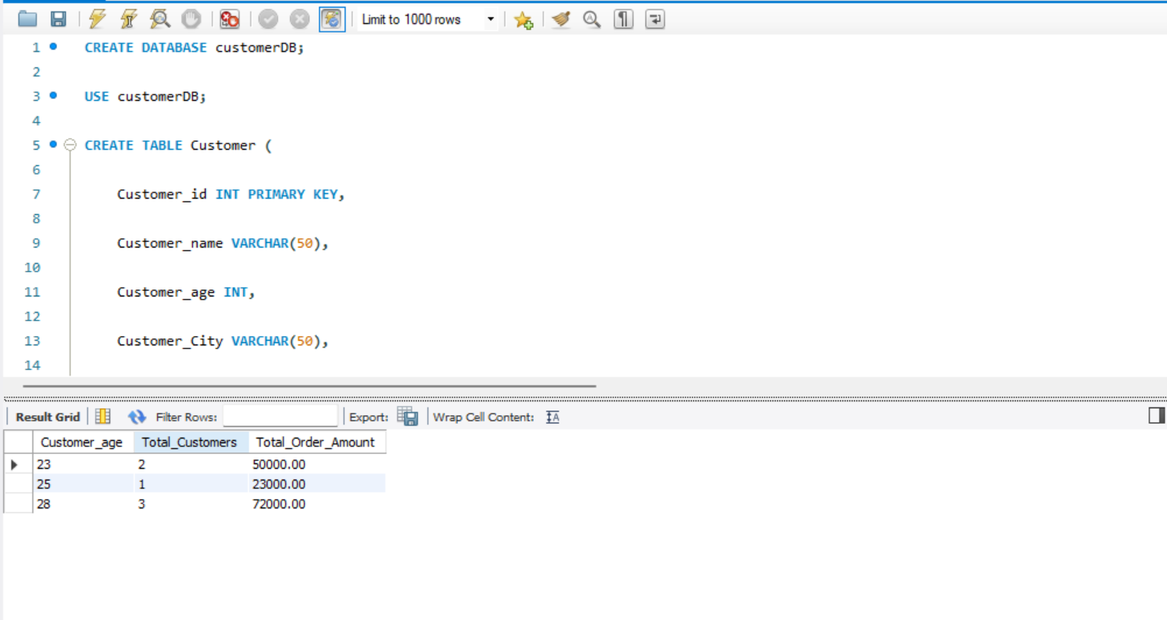

CREATE DATABASE customerDB;

USE customerDB;

CREATE TABLE Customer (

Customer_id INT PRIMARY KEY,

Customer_name VARCHAR(50),

Customer_age INT,

Customer_City VARCHAR(50),

Customer_order_amount DECIMAL(10, 2)

);

INSERT INTO Customer (Customer_id, Customer_name, Customer_age, Customer_City, Customer_order_amount)

VALUES

(101, 'amar', 23, 'bhopal', 25000),

(102, 'rohan', 25, 'bhopal', 23000),

(103, 'sohan', 23, 'up', 25000),

(104, 'kiran', 28, 'up', 21000),

(105, 'Raj', 28, 'ajmer', 22000),

(106, 'Shiv', 28, 'ajmer', 29000);

SELECT *

FROM Customer

ORDER BY Customer_age ASC;

SELECT *

FROM Customer

ORDER BY Customer_age DESC;

SELECT *

FROM Customer

ORDER BY Customer_order_amount ASC;

SELECT *

FROM Customer

ORDER BY Customer_order_amount DESC;

SELECT

Customer_City,

COUNT(*) AS Total_Customers,

AVG(Customer_order_amount) AS Avg_Order_Amount

FROM

Customer

GROUP BY

Customer_City;

SELECT

Customer_age,

COUNT(*) AS Total_Customers,

SUM(Customer_order_amount) AS Total_Order_Amount

FROM

Customer

GROUP BY

Customer_age;